**Program no. -1**

**Objective: To learn and understand the usage of if-else statements**

**Task : To find the greatest numbers of given 3 numbers.**

**Code:**

public static void main(String[] args) {

double n1 = -4.5, n2 = 3.9, n3 = 5.5;

if(n1 >= n2) {

if(n1 >= n3)

System.out.println(n1 + " is the largest number.");

else

System.out.println(n3 + " is the largest number.");

} else {

if(n2 >= n3)

System.out.println(n2 + " is the largest number.");

else

System.out.println(n3 + " is the largest number.");

}

}

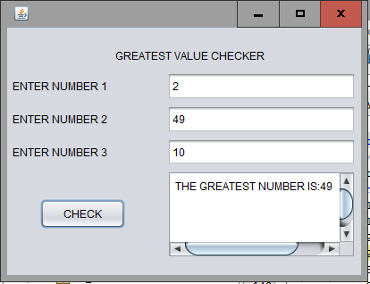 **Program no. -2**

**Objective: To learn and understand the usage of if-else statements**

**Task : Even-Odd Application.**

**Code:**

String s;

int n;

s=tf1.getText();

n=Integer.parseInt(s);

if(n%2==0)

ta.setText("NUMBER IS EVEN");

else

ta.setText("NUMBER IS ODD");

}

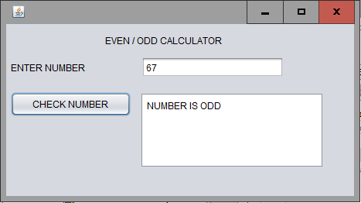 **Program no. -3**

**Objective: To learn and understand the Switch case.**

**Task : Printing of Weekdays based on switch-case**

**Code:**

String s =t f1.getText();

switch(s){

case"1":tf2.setText("MONDAY");

break;

case"2":tf2.setText("TUESDAY");

break;

case"3":tf2.setText("WEDNESDAY");

break;

case"4":tf2.setText("THURSDAY");

break;

case"5":tf2.setText("FRIDAY");

break;

case"6":tf2.setText("SATURDAY");

break;

case"7":tf2.setText("SUNDAY");

break;

default:

tf2.setText("INVALID CHOICE");

break;

}

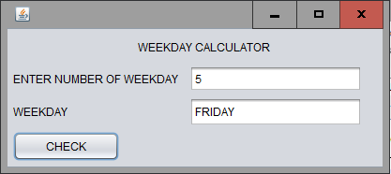 **Program no. -4**

**Objective: To learn and understand the usage of Selection Statements.**

**Task : To make a program which calculates grade for given marks.**

**Code:**

private void jButton1ActionPerformed(java.awt.event.ActionEvent evt) {

String s1=tf1.getText();

int n1=Integer.parseInt(s1);

if(n1>=90 && n1<=100)

ta.setText("A");

if(n1>=75 && n1<= 90)

ta.setText("B");

if(n1>=60 && n1<=75)

ta.setText("C");

if(n1>=45 && n1<=60)

ta.setText("D");

if(n1>=33 && n1<=45)

ta.setText("E");

if(n1>= 0&& n1<=33)

ta.setText("F");

else

System.out.println(0); )

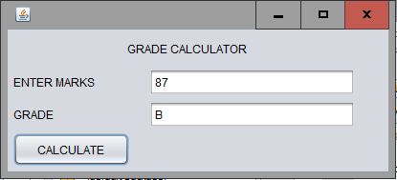

**Program no. -5**

**Objective: To learn and understand the usage of Selection Statements Task :**  **To check wheher a Character is 'Alphabet','Digit' or a 'Special Character'.**

**Code:**

String s;

s=tf1.getText();

ch=s.charAt(0);

if(Character.isLetter(ch)==true)

tf2.setText("ALPHABET");

else if(Character.isDigit(ch)==true)

tf2.setText("DIGIT");

else

tf2.setText("SPECIAL CHARACTER");

}

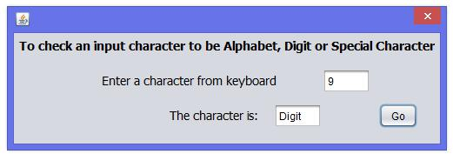

**Program no. -6**

**Objective: : Displaying images on a label and Text Area control.**

**Task : Develop an e-learning application with images and text information as per given screenshot.**

**Code:**

ta.append("Central Processing Unit(CPU) works as the brain of the computer."+'\n');

ta.append("It contains ALU, MU and CU."+'\n')

ta.append("It has a chip called microprocessor"+'\n');

image.setIcon(new

ImageIcon("C:\\Users\\user\\downloads\\cpu.jpg"));}

private void

jButton3ActionPerformed(java.awt.event.ActionEvent evt) {

ta.append("A computer mouse is a hand-held pointing device that detects two-dimensional motion relative to a surface."+'\n');

ta.append("This motion is typically translated into the motion of a pointer on a display,"+'\n');

ta.append("which allows a smooth control of the graphical user interface."+'\n');

image.setIcon(new

ImageIcon("C:\\Users\\user\\downloads\\cpu.jpg"));}

private void

jButton4ActionPerformed(java.awt.event.ActionEvent evt) {

ta.append("A computer monitor is an output device which displays information in pictorial form."+'\n');

ta.append("A monitor usually comprises the display device, circuitry, casing, and power supply."+'\n');

image.setIcon(new

ImageIcon("C:\\Users\\user\\downloads\\monitor.jpg"));}

private void

jButton2ActionPerformed(java.awt.event.ActionEvent evt) {

ta.append("In computing, a computer keyboard is a typewriter-style device which uses an arrangement"+'\n');

ta.append("of buttons or keys to act as mechanical levers or electronic switches.");

ta.append("Following the decline of punch cards and paper tape, interaction via");

ta.append("teleprinter-style keyboards became the main input method for computers.");

image.setIcon(new

ImageIcon("C:\\Users\\user\\downloads\\keyboard.jpg"));

}

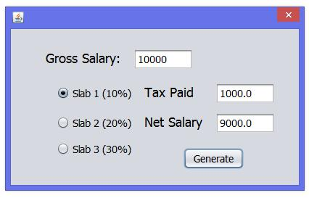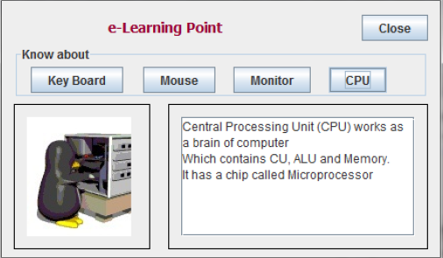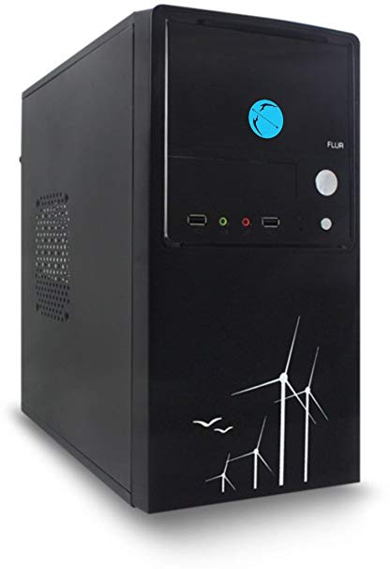

**Program no. -7**

**Objective: To understand and learn the usage of looping statements.**

**Task :**  **Develop an application to calculate sum of n natural nos. and factorial of no.**

**Code:**

**:** int i, f=1, s;

int n=Integer.parseInt(n1.getText());

{for (i=1; i<=n; i++)

f=f*i;

factorial.setText(""+f);}

{s= n/2*(n+1);

sum.setText(""+s);

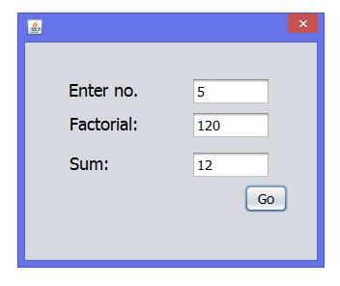

**Program no. -8**

**Objective: Understanding the use of loops and matheatical operations.**

**Task :**  **Develop an application to calculate sum of digits of a number.**

**Code:**

int a;

int b=0;

long n;

n=Long.parseLong(ta1.getText());

while(n>0)

{ a=(int)(n%10); b=b+a; n=n/10;}

ta2.setText(""+b);

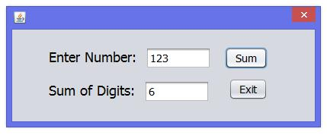 **Program no. -9**

**Objective: To learn and understand the usage of if-else statements**

**Task : Develop an application to check if the input no.**

**is prime or composite.**

**Code:**

int i;

int n=Integer.parseInt(ta1.getText());

for(i=2; i<n; i++)

if(n%i==0)

{ta2.setText("Composite No.");

break;}

else if(i==(n-1))

{ta2.setText("Prime No.");

}

**Program no. -10**

**Objective: Understanding the use of String functions.**

**Task :**  **Develop an application to concat two strings.**

**Code:**

String first=tf1.getText();

String last=tf2.getText();

String full=first.concat(last);

tf3.setText(""+full);

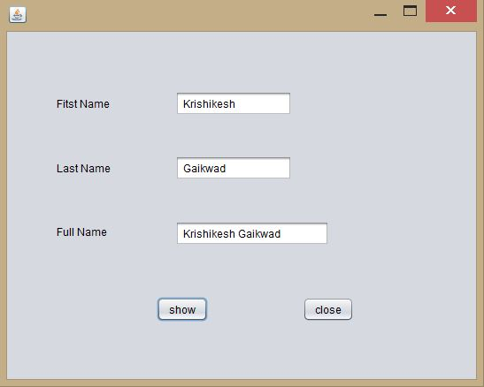

**Program no. - 11**

**Objective: Using String library functions .**

**Task: Develop an Application which takes a string from the user and displays the result using different string functions**.

**Code:**

private void btnStringActionPerformed(java.awt.event.ActionEvent evt) {

String Board = "CBSE";

String str = " Informatics Practices";

Board = Board.concat(str); // Concatenate str with Board

String str1 = "NetBeans IDE Programming";

int ln = str1.length();

String nStr = str1.substring(9); // Index starts from 9th position

String nStr1 = str1.substring(9, 13); // Index start from 9th position till 13th

String uCase = str1.toUpperCase(); // Converts into uppercase letters

String LCase = str1.toLowerCase(); // Converts into lowercase letters

String mess1 = " My Personal Bio-Data "; String Year = "2009";

String nTrim = mess1.trim() + " " + Year;

txtStringArea.append("Concatenated string: " + Board + "\n");

txtStringArea.append("Length of '" + str1 + "' is: " + ln + "\n");

txtStringArea.append("str1.substring(9) is: " + nStr + "\n");

txtStringArea.append("str1.substring(9, 13) is: " + nStr1 + "\n");

txtStringArea.append("str1.toUpperCase() is: " + uCase + "\n");

txtStringArea.append("str1.toLowerCase() is: " + LCase + "\n");

txtStringArea.append("mess1 trim is: " + nTrim + "\n");

}

private void jButton1ActionPerformed(java.awt.event.ActionEvent evt) {

System.exit(0);

}

